
NEWSLETTER JANUARY 2025 – NEW YEAR
NEXT MEETING 6:30 PM Monday, January 20
Chisago County Government Center
Basement Level Conference Room
313 N Main St., Center City, MN 55012

INTERCLUB 2025 COMPETITION
Our January meeting will include preparation for the 2025 Interclub Competition.
Entries must be submitted to the Camera Council online. Submit entries between February 1-March 9. Winners will be announced at SPRING BREAK at Mounds View HS, on April 5th.

TWO DROPBOX FOLDERS FOR JANUARY
Due Midnight, Sunday, January 19
- One to Four Individual Interclub Photos for Feedback – No names embedded.
One-time file naming example:
Ex: YourName.01.Category.ImageTitle
All your photos will be shared together.
- January Photo Assignment – Things that begin with a “P”
Regular club file naming convention:
Ex: 01.YourName.ImageTitle
Photos will be collated by image numbers.

SHARE YOUR PHOTOS ON FACEBOOK
https://www.facebook.com/groups/SCVCC
We regularly feature one club member photo at a time in the header on our club Facebook. Our goal is to feature a photo from each club member over the year. Some members contribute regularly. Please consider contributing one or more images a month. Everyone benefits from broad participation.

2025 ANNUAL DUES
NOTE: Dues remain the same, $20.00/yr. Three ways to pay.
- Pay online via the club website pay page: https://stcroixvalleycameraclub.com/sending-payments-to-scvcc/
- Write a check payable to “Art Reach.”
- Pay in cash. Give checks or cash to treasurer Arlene Jones-Swenson.

WASHINGTON COUNTY HERITAGE CENTER
The camera club hangs pictures provided by club members. We need pictures to hang for the next two months. Pictures should be:
- One to six different people can participate in each exhibit cycle.
- St. Croix Valley subjects and locations.
- Pictures will be changed every two months.
- Prefer 15” x 17” maximum size.
If you would like to volunteer pictures, contact Ken Noyes at < just_me600@yahoo.com > or text at 651-769-4875. Ken will have a signup sheet at the next meeting.

NORTHWOODS ROASTERIE EXHIBIT
The sign-up sheet for the 2025 Northwoods Roasterie exhibit still has openings. Each person gets one month to exhibit one photo. The only requirement is that there is a wire on the back, maximum width is about 20". Contact Doris Staub at dorisstaub52@gmail.com for more info or to sign-up.

2025 HARDWOOD CREEK EXHIBIT PLAN
The SCVCC exhibit at the Hardwood Creek library is March of 2025. The display will include 20 photos. Contact Doris Staub at dorisstaub52@gmail.com to reserve your spot. Sign-up is on a first-come-first-served basis.

CLUB PHOTO SALON AND DIGITAL PHOTOS
Submit all club salon and digital photos in this standard format. Max. 1920 pixels wide and 1920 pixels high. Max. 750KB JPG file size

SCVCC CLUB INFORMATION & CONTACT
Website: https://stcroixvalleycameraclub.com/
Facebook: https://www.facebook.com/groups/SCVCC
Email: stcroixvalleycc@gmail.com

Save the date! 2025 Sneak Peek
Spring Break will be held on Saturday, April 5, 2025, at Mounds View High School, 1900 Lake Valentine Road, Arden Hills, MN 55112 Map Link
Our all-day IN-PERSON speaker is Tony Sweet, a Nikon Legend Behind the Lens. Tony says: “Quite simply, I’ll be presenting all day long. My presentations are about an hour in length and will be on Composition, Minimalism, Creative Camera Efex, Infrared, Panoramic photography, Flower photography, Macro and Close up photography, Long Exposures and more. Questions are encouraged during and after each presentation.” 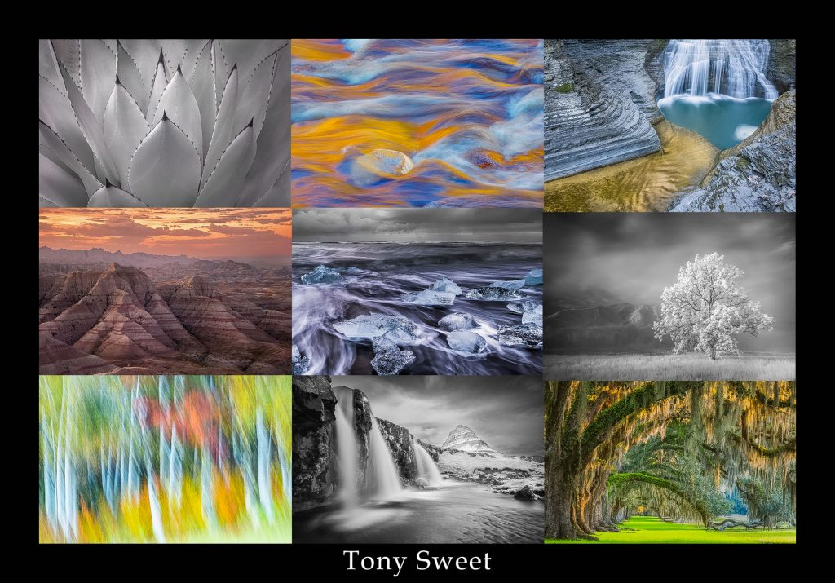
You can expect a full day of learning that includes a box lunch, opportunities to visit with local vendors, door prizes, shooting opportunities, meeting with friends, old and new, and more, including the results of the 2025 Interclub Competition.

The cost this year will be $50.00 and $25.00 for students. Students that register and attend Spring Break will be able to enter up to four images for a special competition. Registration will open in January.
Shooting opportunities during the lunch period will include photographing the University of Minnesota Raptors outdoors and using a portrait studio indoors with Dave Johnson from National Camera Exchange. A table will also be set up with macro subjects and Tamron lenses will be available.
A list of vendors and door prizes will be updated.

Camera Council Spring Break: https://cameracouncil.org/spring-break/

